DESIGN YOUR OWN COAT OF ARMS COMPETITION

BACKGROUND INFORMATION

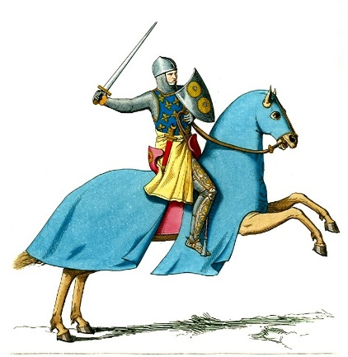
What is heraldry?
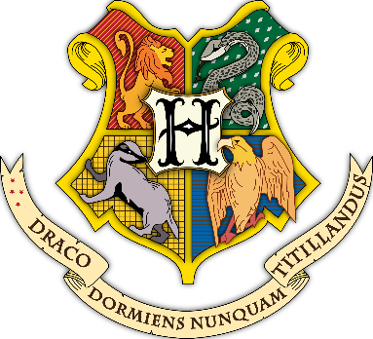
Heraldry is the way in which families and knights could be identified through the use of symbols. The symbols used on a coat of arms are called charges.
By creating coats of arms warriors could be identified on the battlefield when encased in armour and people could be seen as part of a family.
Coats of arms later took on further significance and meanings. They became a way of showing membership in the aristocracy, the highest class of society. This often means Kings and Queens.
Hogwarts Coat of Arms

Designing a Coat of Arms
A coat of arms has several parts.
The main part is a shield, which can have a crest above it, a motto, and animals supporting the shield.
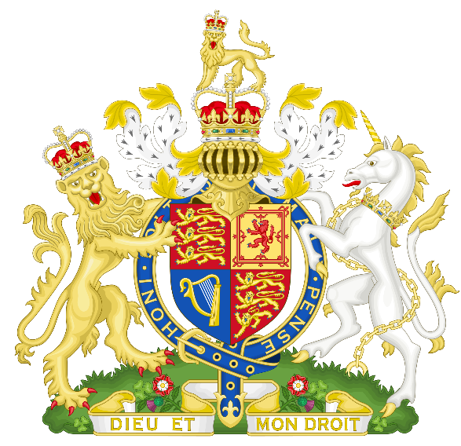

Crest
A golden Lion supporting the shield

Shield
Motto ‘God and my Right’
A chained unicorn supporting the shield

Design your own family (or personal) Coat of Arms

Suggested approach:
- Pick one quality that best describes you. You can use the list below if helpful. For example, wise. Here are some more examples
adventurous | friendly | peaceful
active | funny | pleasant
bold | gentle | polite
bright | generous | popular
brave | good | powerful
calm | graceful | quick
cheerful | happy | responsible
clever | helpful | sensible
confident | honest | serious
cool | hopeful | smart
curious | interesting | thankful
daring | joyful | wise
dependable | kind
determined | lively
eager | loyal
easygoing | mature
energetic | mysterious
excited | nice
fair | noble

2. Match it with an animal who has this quality, for example, a wise owl.
3. Draw this animal in one of the spaces on the shield. Animals are often used on coats of arms and shown looking fierce with red tongues and claws.

4. Choose three more qualities, for example, joyful, brave and bright.
5. Choose three symbols, or charges, that show these qualities. For example, a sun (joyful), a sword (brave) and a lightbulb (bright).
Be playful! Charges are often funny, making a joke about a person’s name or interests.
6. Draw these three symbols in the three remaining spaces on the shield. The background of the shield is called the field. Your field should now be complete with four different charges.
7. Congratulations, you have now designed a divided heraldic shield with four charges.
8. You could also add a motto – what do you think your family motto or personal motto might be. It needs to be something short. The Hogwarts coat of arms has the motto ‘never tickle a sleeping dragon!’

